UNIVERSITY OF MINES AND TECHNOLOGY TARKWA

FACULTY OF INTEGRATED MANAGEMENT SCIENCE

DEPARTMENT OF MANAGEMENT STUDIES

A THESIS REPORT ENTITLED

Formatting Assignment

BY

Akyene Tetteh

Index number

SUBMITTED IN PARTIAL FULFILLMENT OF THE REQUIREMENT FOR THE AWARD OF THE DEGREE OF MASTERS OF SCIENCE IN ENGINEERING MANAGEMENT

THESIS SUPERVISOR

……………………………………………….

DR FRANK BOATENG

(PRINCIPAL SUPERVISOR)

……………………………………………….

DR AKYENE TETTEH

(CO-SUPERVISOR)

TARKWA GHANA

May 2023

DECLARATION

I declare that this thesis is my own work. It is being submitted for the degree of Master of Science in Engineering Management in the University of Mines and Technology (UMaT), Tarkwa. This thesis has not been submitted for any degree or examination in any other University.

………………………………………………

(Signature of candidate)

…………………………………………2024

ABSTRACT

From the findings of the study, it was discovered that the cumulative influence of the green management on organisational performance are significant at 5% which implies that our level of confidence on this result is as high as 95% only 5% is revealed to be term error. Overall, the result from the regression analysis also showed that the from the three components analysed GM_Practice (X1), and GM_Drivers (X3) has a significant impact at the 5% level on Organisational performance (Y). while the GM_Challenges(X2) had a negative but insignificant effect on the organisational performance. Green management policies have significant impact on the organisational performance of SIEMENS. This result was in line with our expectation, as the environmentally friendly policies would lead to higher productivity and impact positively on the overall organisations performance.

DEDICATION

ACKNOWLEDGEMENT

Table of Content

List of Figures

List of Tables

Abbreviations

**Chapter One**

**Introduction**

* 1. Background to the Study

The growing demand for sustainable environmental practices in the production process of goods and services has now become a subject of global concern due to the ever-increasing cases of global warming and greenhouse effects. The global greenhouse emission as reported by the 2014 (Intergovernmental Panel on Climate Change, IPCC) report shows that the industrial and electricity sector jointly contributed 46% of the global greenhouse emission, 24% was from agricultural sector, 14% and 6 was from transportation and building respectively. The remaining 10% was from other sectors as shown in Figure 1.1.

Figure 1.1 Global Greenhouse Gas Emission,

Source: Pachouri et al (2014)

Also, data on global green emission by companies shows that Saudi Aramco emitted an average of 61.14 billion metric tons of carbon dioxide between 1965 to 2018. Followed by Chevron 43.78 billion metric tons, 44.775 billion metric tons by Gazprom, 42. 48 billion metric tons by Exxonmobil, and 36.93 billion metric tons by National oil Iranian. The data on the top 10 companies with the highest average green emission between 1965 to 2018 is shown Figure 1.2 below.

According to Onwudiwe et al. (2019), more than 313 million standard cubic feet of gas are flared by oil companies in Nigeria annually, leading to 16.5 million tons of carbon dioxide emissions. Therefore, this stresses the need to adopt principles, policies, and practices of green management by these companies to enhance the customers, employees, and host community quality of life. They argued that companies whose activities generate the greatest negative externalities must start with the willingness to resolve the environmental effects of their operations

Due to the growing trend of green emissions and the growth of industrial activities it has therefore become more important than ever for firms to look out for a more environmentally friendly practices or what is known as “green management” to reduce the negative environmental externalities generated in the production process (Amahalu, 2020). According to Amahalu (2020), green management is also referred to as “corporate sustainability” or “environmental management”. Jermsittiparsert, et al. (2019) view green management as the activity of an organisation directed towards a steady developmental adjustment on the environmental operations of the organisation. According to Haden, et al. (2009), green management is a wide range of processes of adopting technological innovations in other to accomplish sustainability, social responsibility, reduced waste, and maintain a competitive edge through incessant development by learning and adopting strategic environmental objectives which are fully incorporated and compatible with the organisation’s aims and strategies.

Figure 1.2 Average Global Emission by Companies. Source: Statista (2021)

The go green initiative is an exertion that will reduce organisation’s pollution and carbon emissions through the impact of greenhouses on planet Earth. Moreover, it consists of three activities, namely recycling, shortening and reuse. These three main activities mainly help to reduce the burden of human activities by industrial activities. By such an important activity in the organisation’s activities, thus recycling, shortening and reuse, management can prevent and reduce the impact on the environment. However, organisational management needs to be updated and adapted green technologies with environmentally friendly policies before this movement can continue (Shah et al, 2016).

The growth of green management has drawn the attention of researchers and claims that some researchers have attributed the importance of green management due to the growth of stakeholders’ that managers are obliged to take responsibility for when utilising resources (Rawashdeh, 2018). For Green et al. (2012), green management is now a method seen as new strategic management targeted at accomplishing a full-grown sustainable business whose outcome will be financially, socially, and environmentally visible. They further stressed that the concept is an integral part of developing sustainable business categories, thus resulting in a declining negative environmental impact during business operations. More importantly, Adediran and Abdulkarim (2012) have acknowledged the existence of standards that guide companies in supervising the environmental impact of their present activity, such as ISO 14000 wholesomely. Omole and Isiorho (2011) stated that ISO 14000 is an environmental management system (EMS) that serves as the guiding principle of companies’ environmental actions, which also serve as an instrument for acquiring a competitive advantage. Amahalu (2020) noted that EMS is a structure built to accumulate information, weigh progress, and improve such progress. This suggests that green management in an organisational context should involve the formulation and implementation of adequate environmental policies that will improve the degree of environmental caution or bring about a reduction of the negative environmental impact of an organisation by adopting suitable technology, also referred to as “Green” that will be of benefit to the organisation and its customers (Adediran and Abdulkarim, 2012).

Most literature focuses more on conceptualising green management (Skibinska and Kott, 2015) without much empirical literature on factors beyond customer demands that can lead to the implementation of green management, how to execute it effectively, and the extent to which firms adopt green management practices. On the other hand, other authors paid attention to the concept and consequences of green innovation (Cuerva et al. 2014) alongside green supply chain management (Mongina, 2015; Mugabe, 2013, Sulistio and Rini 2015). Although these are significant subject of discussion, it still fails to capture why firms are reluctant to embark on green management and the extent to which green management practices are adopted by practising firms. This study gap creates room for relevant research that will focus on the factors that influence the utilisation of green management practices and the extent to which green management practices are being practised. Hence this study fills the identified gap by studying the extent of green management utilisation in an engineering firm.

1.2 Statement of Problem

Responsiveness of the science and art of logistics remains a subject of research. Furthermore, considerable publicity of reverse logistics management has been irritated. However, several businesses that formerly did not dedicate considerable energy or time to understanding and reverse managing logistics have now started paying attention to the subject. These businesses are benchmarking reverse practices with best-in-class operatives. Several manufacturing companies are even becoming International Standards Organisation proficient in their reverse procedures (Rogers and Tibben-Lembke, 1999). Research on reverse logistics has focused on the sustainable construction process, economic and environmental issues (Calkins, 2009; Giang and Pheng, 2011), but there has been little work exploring reverse logistics practices.

Researchers highlighted that reverse logistics practices produce social, environmental, and economic difficulties. However, reverse logistics is prudently helpful, as it protects the cost of materials by recycling materials, making money from the convalesced materials, and reducing the cost of procurement, waste disposal, transportation, inventory, and the preservation of new goods but is without challenges (Marzouk and Azab, 2014). Arif et al. (2012) showed that reverse logistics application in the mining industry is still restricted. Nunes et al. (2009) contended that the implementation of reverse logistics in Brazil's construction sector is a result of minimizing waste through reusing. Chileshe et al. (2016) mentioned that reverse logistics are applied in India by resending components to suppliers, recovered materials, and manufacturers to manage waste. Arif et al. (2012) recognized that the purpose of reverse logistics application at the project level is to decrease waste. It appears that the reverse logistics concept is deliberated chiefly upon in the construction industry, emphasizing end-of-life waste management. This study will focus mainly on reverse logistics at Kaltire.

1.3 Research Objectives

The basis for this research is to assess Reverse logistics management of used heavy mining equipment parts in Kaltire, Ghana. The specific objectives are to;

1. Identify the return practises of reverse logistics at Kaltire Ghana.

2. Examine the challenges in reverse logistic practises at Kaltire Ghana.

3. Determine the impact of reverse logistics on the company’s performance.

1.4 Research Questions

1. What are the return practises of reverse logistics at Kaltire?

2. What are the challenges in reverse logistics practises faced at Kaltire?

3. What is the impact of reverse logistics on the company’s performance?

1.5 Justification of the Study

This study will offer a basis for a standard and conceptual framework against which organisations could evaluate their reverse logistics management structure and review their efficiency. Furthermore, this research will offer an understanding, a common language, and a valuable means to assess and improve organizational reverse logistics management systems. One other justification of this study is that it will provide ways of researching what this research could not cover, considering its limitations. This will be of good importance and a guide for researchers studying the same or similar subject.

The outcomes of this research work will assist the companies in following the reverse logistic control procedures in their daily operations. Furthermore, although this thesis is to moderately accomplish an academic obligation for an award of a second degree, it is anticipated that suggestions will be offered to supplement the procedures by the regulatory bodies and the companies' efforts in addressing challenges related to the procedures of reverse logistics management systems. Lastly, it will seek to add to the existing literature and knowledge and serve as a pivot for future research work in reverse logistics management.

1.6 Scope of the Study

The research work focused on reverse logistics management of used heavy mining equipment parts and the return practices of reverse logistics. Again, the study concentrated entirely on the challenges in reverse logistic practises in the mining companies in Ghana; the study also looked at the impact of reverse logistics on the company’s performance.

Furthermore, the study is a single case study focusing on Kaltire Ghana. This research work also centered on the responses of the management and staff of Kaltire Ghana in Tarkwa in the Western Region. The assessments also examined all areas of reverse logistics management with a particular focus on return processes in accordance with sustainable logistics procedures, including the impact on the company’s performance. Finally, this study geographically focused on Ghana as a developing country with promising mining industry.

1.7 Limitations of the Study

These constitute the limitations of this research work; First is the reluctance of confident respondents to respond to questions, which generated an initial difficulty in the data-gathering procedure. This was nonetheless efficiently controlled to avoid any inconveniences. Again, the research work faced some challenges in inadequate funding to conduct a lengthy examination into other pertinent fields related to the subject understudy. And lastly, the researcher also had to combine the research work with her regular daily routine of work and family life which also caused some challenges in the data-gathering process.

1.8 Research Organisation

This thesis is divided into five interconnected chapters, including the chapter introduction. The remaining research work is as arranged: the second chapter presented the existing theories about the subject of study, the review of the literature, and the conceptual framework of the study. It also engaged the discussion and review of already known literature and research works that have been done on the topic under investigation and their possible inferences on the current study under way.

The third chapter examined the study's chosen research approach. In addition, the chapter detailed the study design, sample strategies, data-gathering sources and methods, and the data analysis process. The fourth section of the study focused on a thorough examination, discussion, and interpretation of the research findings in graphs, tables, and other quantitative calculations. Finally, the last chapter included the results, conclusions, and suggestions.

**Chapter 2**

**Literature Review**

**Introduction**

This chapter provides the conceptual, theoretical and empirical reviews of the project. It begins with a description of the mining assets and the mining business portfolio. The conceptual review contains the description of maintenance and its impact, relation between the Plant maintenance and production, plant utilisation and production, maintenance and profitability, maintenance and productivity and maintenance cost. This chapter also include theories that has been adapted for use with related empirical reviews and studies conducted in maintenance profitability and productivity. It concludes with the conceptual framework and the chapter summary.

**Mining Asset and Its Importance**

Most mining assets are divided into two main categories: projects and operating mines (Anon, 2015). Projects in the mining industry may be divided into exploration and feasibility phase then planning and construction phases. A mine officially becomes operating mine when the asset is ready to commence. There are mineral assets, equipment assets, infrastructural assets and human assets within the category of operating the mine. These assets constitute the business portfolio of gold production.

Mining requires prudent optimization of the operations aimed at improving performance indicators such as efficiency, overall equipment effectiveness (OEE), productivity and profitability. These indicators, being measures of production are affected by operational variables and challenges that result from maintenance and asset utilisation (Quarshie et al, 2017).

**The Mining Process**

Operations in mining consist of a series of distinct sequential stages that complements efficient operation. The operation performance of one stage may affect the other. Optimizing any of the functional stages disjointedly and not considering the whole processes may end up not achieving the optimum efficiency of the entire mine (Anon, 2012). Figure 2.1 shows the core activities of the mining industry from exploration, extraction, processing, logistics to support services (Anon, 2012).

**The Mineral (Gold) Processing**

The processing stage requires the comminution, which is the reduction of size to allow the liberation of gold material. The process is separated into wanted and unwanted material. The wanted material is concentrated into transportable form. The unwanted material is disposed as tails. Figure 2.4 shows the mineral processing. All these processes are achieved through equipment which requires to be kept in a certain machine state to be able to achieve set targets (Lofsten, 2000). Equipment in a certain state requires certain level of maintenance which will give the desired purposes.



Figure 2. 1 Mining value chain

Source: PwC Asia School of Mines (2012)

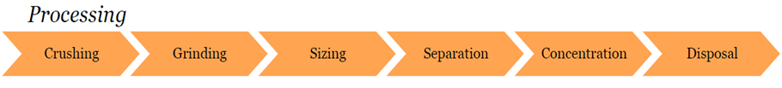

Figure 2. 2 Ore Steps in Ore Processing

Source: PwC Asia School of Mines (2012).

**Maintenance Management**

Impact of Maintenance

Maintenance according to the British Standard BS4778-3.1:1991 or BS 3811:1993 (or MIL-STD-721B) is defined as a method of maintaining an item in an operational state by either preventing a transition to a failed state or by restoring it to an operational state following failure. Maintenance is thought of as a mixture of technical, administrative and managerial actions through the life cycle of any unit intended to retain it in or restore it to a state that it will perform its required function (Rastegari, 2013).

Maintenance involves engineering decisions and associated activities which are necessary for the optimization of specified equipment capability, which is the ability to perform a specified function within a range of performance levels (Kumar et al ,2014, Khairy et al, 2008 and Al Turki et al, 2014). These performance levels relate to utilisation, quality availability, reliability, responsiveness and safety. Maintenance objective is therefore on total asset life cycle optimization. This implies making the most of the availability and reliability of the assets to produce the desired quantity of products in a cost‐effective manner and in accordance with environmental and safety regulation (Kumar et al., 2014 and Khairy et al., 2008).

Maintenance costs is one of the major constitutuants of total operating costs for manufacturing or production plants. Depending on the particular industry, it can constitute of about 15 to 60 percent of the cost of production. Maintenance management effectiveness from a recent survey indicates one-third (33 cents out of every dollar) of maintenance costs due to unnecessary or improperly maintenance is wasted (Mobley, 2002).

Traditionally, there are two main types of maintenance systems in a process plants. These are Preventive maintenance and run-to-failure. Run-to-failure maintenance relies on the principle of running the equipment to an inevitable point of breakdown and then fixing it, whiles preventive maintenance is a planned maintenance that relies on elapsed time or hours of operation (Mobley, 2002). Over the years, requirements of maintenance on processes and systems have resulted in developing concepts such as Predictive Maintenance, Total Productive Maintenance (TPM), Total Quality Maintenance (TQM) and proactive maintenance seeking to improve upon the maintenance function.

The Maintenance System

Maintenance activity basically operates in parallel with production therefore, it is imperative to make production equipment and support units be in good condition, maintainable and safe to operate (Raouf, 1994). Figure 2.3 shows a typical maintenance management system. Maintenance system effectiveness involves the following separate units of work; maintenance, inspection and verification. These may be carried out by different work groups in that company or subcontracted to other companies (Misra, 2016).

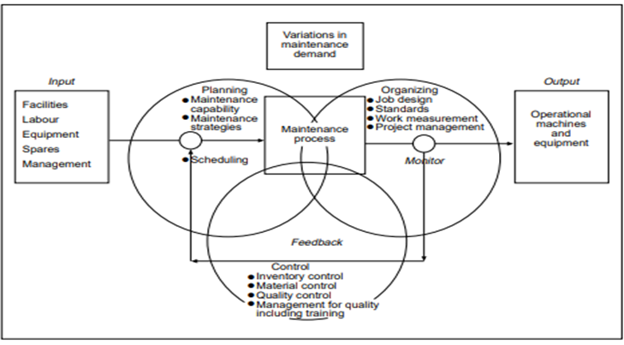

Figure 2. 3 Maintenance System

Source: Raouf (1994).

Maintenance task is divided into two main categories planned and unplanned maintenance (Misra, 2016 and Enofe 2010). The planned maintenance include preventive, predictive, or corrective. The unplanned maintenance is primarily corrective and emergency maintenance to restore failure. The maintenance system is supported by strategies that result into forms of maintenance such as Pre-plan, Planned, Shutdown, Breakdown and Emergency Maintenances (Misra, 2016). There are many maintenance approaches that is, strategies and concepts that are in operation as suggested by intellectuals. The two terms are mostly used interchangeably.

Maintenance Concepts and Strategies

Maintenance concept is defined as a set of various maintenance interventions (corrective, preventive, condition based, etc.) and the structure in which these interventions are expected. The maintenance concept is the frameworks on which maintenance strategies are established. This is an embodiment of the way of thinking of a company on the role of maintenance as an operation function (Waeyenbergh and Pintelon, 2002). Some advanced maintenance concepts include reliability-centred maintenance (RCM), total productive maintenance (TPM) and business centred maintenance.

Maintenance strategy involves the identification, researching and executing repair, replace and inspect decisions (Kelly, 1997). The strategy formulates the best life plan for each unit of the plant and formulates the optimal maintenance schedule for the plant in conjunction with production and other functions concerned (Alsyouf, 2007). A maintenance strategy describes what events (e.g. failure, passing of time, condition) trigger what type of maintenance action (inspection, repair, or replacement). A maintenance strategy consists of a mix of policies and or techniques, which vary from facility to facility (Alsyouf, 2007). The maintenance strategy is dependent on factors such as the goals of maintenance, the nature of the equipment or facility to be maintained, workflow patterns (process focus, product focus), and the work environment (Alsyouf, 2007).

Maintenance strategies are based on the timing and work contents as is evident in the work management categories and activities (Misra, 2016). The work management categories are;

1. Timing known, Content known: This includes pre-planned maintenance (PPM), planned shutdowns, routine inspections and schedules change-outs fall in this category.
2. Timing known, Content unknown: Statutory surveys and third-party inspections as well as condition-based maintenance.
3. Timing unknown, content known: Anticipated maintenance work, contingency work awaiting shutdown and run to destruction.
4. Timing unknown, content unknown: Breakdown maintenance, immediate repairs arising from inspection, and to run to failure.

**Table 2.1 Work Management Category**

|  |  |
| --- | --- |
| Time Known Content Known | Time known Content Unknown |
| Time Unknown Content Known | Time Unknown Content Unknown |

Source: Misra, (2016)

It is always a preferred choice for in work management when work activities fall in category one and that of category four is the least welcome (Misra, 2016).

*Types of Maintenance Concepts or Strategies*

There are several maintenance approaches in place according to literature based on maintenance agenda (Misra, 2016). Predominantly used are the preventative, corrective, predictive maintenance strategies.

Preventive Maintenance

Preventive maintenance is a schedule planned maintenance activities intended to prevent future breakdowns and failures of a system that is functioning correctly (Misra, 2016). All preventive maintenance management programs are time driven. That is, maintenance tasks are based on elapsed time or hours of operation (Mobley, 2002 and Misra, 2016). All equipment have statistical lives, which behave just like the bathtub curve indicated below;

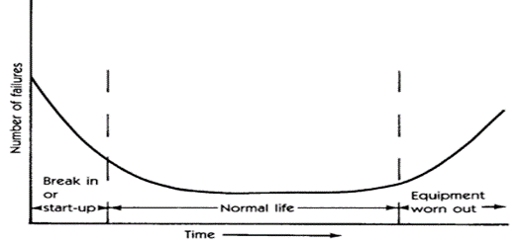

Figure 2. 4 Typical Bathtub Curve

Source: Mobley (2002)

The bathtub curve also called mean-time-to-failure (MTTF) provides the nature of every machine from new to old. So, the probability of a new machine failing in the first weeks of operations is high because of installation problems. After the initial period of operation, the probability of failure is low for an extended period. This probability of failure increases with elapsed time after the normalcy period. So, in preventive maintenance management, machine repairs and rebuilds are scheduled based on the mean time to failure (MTTF) statistic (Mobley, 2002). Every The preventive maintenance program objective is either to minimize the overall costs (or downtime, replacement cost etc) and meet a reliability or availability goals (Misra, 2016).

Corrective maintenance

Corrective maintenance consists of the actions taken to restore a failed or failing equipment or system to operational state (Misra, 2016). This type of maintenance mostly involves replacing or repairing the component that caused the failure of the overall system. Corrective maintenance has no predicted time intervals to be performed because a component's failure time is not known a priori. Corrective maintenance has 3 steps (i) Diagnosis of the fault, (ii)Repair or replacement of faulty components (iii) Verification of the repair action.

Predictive Maintenance

Predictive maintenance philosophy is based on the use of equipment operating conditions to optimize total plant operation (Misra, 2016). An efficient predictive maintenance management program uses tools such as vibration monitoring, thermography and tribology to assess the actual operating condition of critical plant systems. the data gathered are scheduled and executed on an as-needed basis. The benefits of predictive maintenance are derived optimal availabilities that affect plant run time at a greatly reduced maintenance cost. This type of maintenance improve product quality, productivity, and profitability of manufacturing and production plants (Mobley, 2002).

Again, predictive maintenance is a condition-driven preventive maintenance program that uses direct monitoring of the mechanical condition, system efficiency, and other indicators to determine the actual mean-time-to-failure or loss of efficiency for each machine-train and system in the plant (Mobley, 2002 and Misra, 2016). In effect, condition monitoring or predictive method uses relevant acceptable means to determine equipment condition and predict potential failure. This may include the use of the human senses (appearance, sound, feel, smell), machine performance monitoring, and statistical process control techniques. (Misra, 2016).

Other Maintenance Improvement Method

Maintenance requirements over the years have given rise to improvement methods above the usual strategies and concepts. Improved methods such as total productive maintenance (TPM) and reliability-centred maintenance (RCM) are used to resolve ineffective maintenance management systems.

*Total Productive Maintenance (TPM)*

TPM is defined as a low-cost, people-intensive system for maximizing equipment effectiveness by the involvement of all the company’s departments and functions in a preventive maintenance system (Raouf, 1994 and Mobley, 2002). TPM quantified benefits are contained in terms of capacity, product quality, and total production cost (Mobley, 2002). Key supporting elements of TPM are equipment, workers and quality maintenance (Raouf, 1994 and Mobley 2002).

*Equipment*

The objective of productive maintenance is to have equipment capable of attaining high operating times. This is achieved through a maximized mean time between failures (MTBF) by optimizing the frequency of scheduled maintenance. Equipment effectiveness includes equipment availability, performance efficiency and rate of quality of output (Raouf, 1994). TPM concepts adheres to the basic activities of lubrication, visual inspections, and universal use of best practices in maintenance (Mobley, 2002). Equipment role in TPM is to bring into the system an exclusive technology meant to introduce low-cost, specific-purpose machines into operation. other factors considered include a automation level, degree of maintenance required, ease of start-ups, life cycle costing and energy consumption (Raouf, 1994).

*Workers*

The core of TPM is the corporation among the production, maintenance, engineering, and technical services to improve overall equipment effectiveness (OEE). Workers’ involvement entails two things: Workplace organization and worker training. The aim is to create awareness on the organization, orderliness, attention to details, cleanliness, and discipline to workers. Another focus is dissemination of maintenance and engineering knowledge (Raouf, 1994).

*Quality Maintenance*

quality maintenance aims at achieving zero production equipment failures. The focus of quality is the elimination of the six-crippling shop-floor losses:

1. Equipment breakdowns
2. Setup and adjustment slowdowns
3. Idling and short-term stoppages
4. Reduced capacity
5. Quality-related losses
6. Start-up/restart losses

Generally, TPM is improving equipment effectiveness through its five fundamental pillars (Mobley, 2002). These include,

1. Improve equipment effectiveness.
2. Involve operators in daily maintenance.
3. Improve maintenance efficiency and effectiveness.
4. Educate and train personnel. (The most important in TPM).
5. Design and manage equipment for maintenance prevention.

*Reliability-Centred Maintenance (RCM)*

RCM is an advanced form of both preventive and predictive maintenance approaches.

It involves systematic process of preserving an assets function by selecting and applying effective preventive maintenance tasks (Misra, 2016). Its approach helps in deciding what maintenance tasks should be performed at any given time (Misra, 2016).

RCM techniques commence with establishing the expectations of the system to be applied on, followed by identifying all the failure modes the system can be in. it is followed by performing failure modes and effects analysis (FMEA) or failure modes and effects criticality analysis (FMECA) to identify root causes of these failure modes. Out of these application, the appropriate combination types of maintenance are selected, scheduled and planned. The maintenance plan is implemented and data are collected to refine and improve the maintenance schedule (Misra, 2016). RCM is based on the use of the P-F curve which believes every equipment will degrade and fail with time hence, (FMEA) and Weibull distribution analysis are used to predict when these failures will occur (Mobley, 2002).

The initial cost of implementing RCM approach is very high and often results in successful investment, but there are some cases of unsuccessful implementations which require a prior economic evaluation before its adoption (Misra, 2016).

**Maintenance Profitability**

Profitability is the ability of a business to earn a profit (Grimsley, 2015) and by definition, it is the product of productivity and price recovery inferring from the American Productivity and Quality Centre (APQC). The functions of Profitability are the interactions between controllable and uncontrollable factors (Alsyouf, 2007). The uncontrollable also known as external factors are the economic and political environment, market decline or growth, inflation, and so on. The external factors may pose a significant impact on profitability (Loggerenberg *et al*., 1981). Controllable factors are those that affect productivity through capacity utilisation, maintenance, economy of scale, worker, and material quality (Tilton, 2014). Factors that impact on profitability are measured to know whether changes in profit margins are the cause of changes in these factors (Alsyouf, 2007).

Companies have two ways to achieve profitability using competitive advantage through effective maintenance; Low cost and Differentiation (Enofe,2010). To achieve low cost, companies uptight on cost control, use economies of scale and minimise cost of other support services that need to be attained. Differentiation on the other hand, is the offering of a perceived unique products (Enofe, 2010). These together help achieve a company’s goal of good profitability; a return on investment (ROI).

**Maintenance Productivity**

Productivity measures how well input resources are used to produce the outputs; goods or services (Coka, 2014). It is defined as the ratio of output quantity in a specified time to the sum of one or all input factors required to produce the output quantity such as manpower, materials, and energy (Alsyouf, 2007 and Anon, 2016). Productivity is how efficient and effective production is made (Alsyouf, 2007 and Anon, 2016). Therefore, an increase in the improvement of production does not necessarily mean an increase in productivity. Productivity and efficiency are distinctly interpreted but in practice, it is the relationship between production output and maintenance input (Löfsten, 2000). This implies that, a process or a system must be efficient and effective to become productive (Sumanth, 1998).

The concept of productivity can be applied to any business or department and the outcome productivity ratio or index can be computed for an operation, an organisation a department, a facility or a country (Löfsten, 2000 and Coka, 2014). Figure 2.6 represents how a productive system behaves.

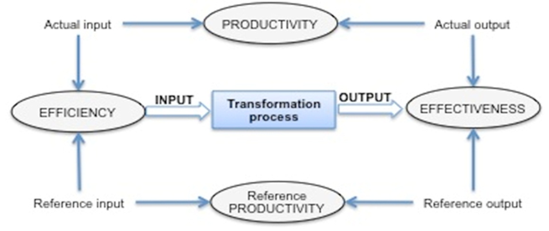

Figure 2. 5 Efficiency versus Effectiveness versus Productivity

Source: Anon (2016)

The productivity level of a company impact directly on a its profits generation. More work completed or products produced implies resources are utilised better and impact on profits becomes bigger within the time period (Coka, 2014). Negative impact on productivity is not only attributable to operational deficiencies, but gaps in maintenance, reliability, asset utilization, operational planning and control (Lala *et al*., 2015).

Input and Output

Input refers to the resources consumed or expended in taking a course of action (Löfsten, 2000). Output measures the outcome in terms of resources based on taking the course of action (Löfsten, 2000). There are many options of calculating productivity using output over input formula. Input and output are used for calculating labour productivity, machine productivity, capital productivity, energy productivity, and many more. Productivity can be increased using input and output through the following ways:

1. Increasing the numerator (output) while resources (input) reduce,
2. Increase the output (numerator) while resources (input) remain constant,
3. Decrease the input (denominator) while output remain constant,
4. Increase input and output, but output increases faster than input: or if
5. Decrease input and output but input decreased faster than output.

In maintenance, the inputs are resource materials, labour, and equipment. Maintenance output are mill reliability and availability. The operations input are mill availability, resource materials, labour and equipment. The operations output are mill utilisation and throughput.

*Methodology of Productivity*

There are two methodologies involved in measuring the productivity concept: The aggregate and the component productivity. The aggregate productivity measures and evaluates the performance of a large collective body (a plant, division, company, or an industry) over an extended time frame. The aggregate measure index relates to current period performance to performance of a base period adjusted to real unit terms to facilitate comparison. The index, expressed in real unit terms, should be free of the distortions in units’ costs from the impact of inflation (Löfsten, 2000). Component productivity measures the performance of ane activity or small organisational unit (Löfsten, 2000).

Profitability and Price Recovery

Price recovery is a measure of the ratio of the price of the output products to the allocated cost of the consumed inputs units (Prokopenko, 1996 and Alsyouf, 2007). Price recovery is considered as an uncontrollable factor that affects profitability since it is most attributable to some other factors (Alsyouf, 2007). These factors influence the products’ price or input costs.

Maintenance and Cost

Equipment maintenance forms an important role in any industry’s cost management. Effective operation and maintenance practises centred on good maintenance may significantly lead to cost reduction (Morad *et al*., 2013). Maintenance costs is one major constituent of total operating costs for all manufacturing or production plants (Mobley, 2002). Maintenance costs, depending on the type of industry, may represent between 15 and 60 percent of the cost of production (Mobley, 2002). It is important for manufacturing companies to stay competitive through minimization of production costs (Raouf, 1994). From literature, improvement in maintenance is achieved by reducing downtime, minimizing maintenance costs and improved production equipment effectiveness such as total productive maintenance (Raouf, 1994). Generally, improvements in maintenance is aimed at reduction in operating costs and improved production outcome (Alsyouf, 2007).

*Maintenance Cost Types*

Maintenance cost is typically divided into direct and indirect costs without considering maintenance savings and profit (Alsyouf, 2004). Direct costs include cost that relates to internal and external (outsourcing) maintenance activities (Enofe, 2010). Furthermore, direct maintenance costs are directly associated with activities of internal costs required to execute maintenance functions such as labour, tools, spare parts, training and other directly related maintenance expenditures (Al-Najjar, 2007 and Alsyouf, 2004).

Indirect costs include all costs that are not directly related with maintenance. These are attributable to profit or loss due to production losses through stoppages (unplanned and planned), loss of good will and loss of market share due to factors of maintenance. Indirect cost also include inefficient cost performance as a result of reduced speed, maintenance quality cost, idle fixed cost such as idle machine and worker cost in breakdowns, delivery delays, penalty cost as a result of unplanned down time (Al-Najjar, 2007 and Alsyouf, 2004).

**History of Gold Price**

Over a span of 20-years, the mining industry has experienced gold price fluctuations surging from $200 per oz to a maximum $2000 per oz and over. These resulted from external factors ranging from supply demand and investor behaviour, political, speculation, inflation prospects, lack of safe havens etc., (Boyle *et al*, 2021). Figure 2.7 shows gold price fluctuations over a 20-year period.

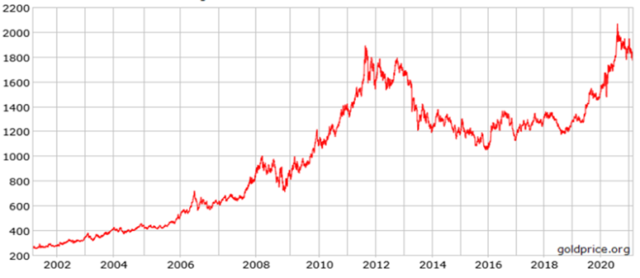

**Figure 2. 6 20-year Gold price in USD/oz-**

**Source: Anon (2020)**

**Theoretical Review**

The impact of maintenance on any business is assessed based on its efficiency and reliability at achieving set targets. Measures of maintenance are mostly on the availability of the process and producing at a minimal cost. Equipment effectiveness and efficiency to deliver on its intended purposes are related to people and equipment management. In view of these, theories available on maintenance and its impact are based on people and equipment use efficiencies.

APQC Profitability Model

The APQC model is an acronym for American Productivity and Quality Centres (APQC). It establishes that business profitability is a product of productivity and price recovery represented in the equation:

$Profitability=Productivity ×Price Recovery$…………………………………….………... (1)

This equation can also be rewritten as;

$$Profitability= \frac{Output }{Input} × \frac{Price}{Cost}……………………………………………………..(2)$$

Where productivity is a measure of the output over input employed.

The productivity Theory

Productivity theory based on production theory seeks to maximize productivity in economic terms and aims at producing any output decided upon at minimum maintenance cost (Löfsten, 2000). Productivity can be measured for a single process (partial productivity), more than one process (Multi-factor productivity) and an entire process (total productivity).

*Partial Productivity*

Productivity measurement answers the question of how much input is required to achieve an output (Löfsten, 2000). A useful measure of productivity is partial productivity. This measures the total output divided by one kind of input (Löfsten, 2000).

$$Partial Factor Productivity=\frac{Total Output}{Single Input}………………………………………….(2.1)$$

The partial productivity index measure reflects how good a plant is turning maintenance inputs into production output in dollar terms. If the interest of measure is on labour productivity, labour hours will be used and be converted into dollars and added up to the other inputs ((Löfsten, 2000).

*Multi-factor Productivity Measure (MPM)*

Multi-factor productivity considers two or more inputs, such as labour, capital, materials, energy, etc. In calculating MPM, all units of factors are converted to dollars for the purpose of achieving uniformity.

$$Multi-Factor Productivity=\frac{Total Output}{Input\left(two or more\right)}…………………………………(2.2)$$

*Total factor or Multi-factor Productivity Measure (TFPM)*

Total factor or multi-factor productivity considers all inputs, such as labour, capital, materials, energy, etc. Total factor Productivity Measure (TFPM) shows a broader picture of a firm’s productivity than partial productivity measures (Prokopenko, 1996). In calculating MPM or TFPM, all units of factors are converted to dollars for the purpose of achieving uniformity

$$Multi-Factor Productivity=\frac{Total Output}{All Inputs}…………………………………………(2.3)$$

Profit Maximization Theory

Profit maximization theory is a neoclassical economic theory that dwells on profit maximization. Most organisational business objective typically in a traditional economic model seeks to maximise short-run profits, that is, profits in the current period generally a year (Tripathi, 2019). Profit is therefore the difference between the total revenue and total cost. This means revenues are maximized at a minimal cost to produce profits for the business. The economic profit is given as;

$Profit \left(π\right)=Total Revenues-Total Cost………………………………………….(2.4)$

This concept of cost used is about economic theory and managerial economics and not the cost concept of accounting by accountants. It is this economic profits that organisations attempt to maximise in their decision making about the level of output to be produced and pricing for its product. So, according to Tripathi (2019), any business to increase profit margins must,

1. increase total revenue more than increase in costs.
2. cause increase in revenue, and costs remain unchanged.
3. reduce cost more than it reduces revenue.
4. reduce costs and revenues remain the same.

Maintenance Theory of Reliability (RCM)

Reliability theory is a study of useful and practical maintenance models that entails replacement, preventive maintenance and inspection. The main aim of reliability maintenance approach is to reduce the total costs with failures and downtimes. This theory helps also to improve the system availability, optimise spare parts inventory, identify component failure significance and hidden failure modes, opportunities for system engineers and operations personnel, and Identifying areas for potential design enhancement (Mobley, 2002).

**Empirical Review**

The empirical review considers research in similar or related fields where studies have earlier been conducted. Unfortunately, there is limited available research of maintenance impact on business profitability in gold production industry. Therefore, review considers subject matter in other fields of maintenance.

Application of Maintenance for productivity improvement

Morad *et al*., (2014) investigated optimal maintenance application process for minimizing the equipment breakdowns and downtimes in Sungun Copper Mine. Field operating data of 10 trucks were used to estimate the failure and maintenance profile for each component. Reliability block diagram method was used to accomplish the modelling and simulation. The analysis identified items with critical impact on availability of overall equipment helped to prioritize improvement decisions. This resulted in the improved efficiency and productivity of the equipment and lowered expenses in addition to the increased profit margins.

Measuring Maintenance productivity index

Löfsten (2000) focused on finding a suitable productivity index and used a model on maintenance productivity which determined whether to schedule preventive maintenance and trade- of the capital costs of preventive maintenance and the sum of corrective maintenance and downtime costs. The research suggested that when the total maintenance costs and down-time costs are reduced to a minimum within a production rate then good productivity would be achieved. The research iterated that maintenance and reinvestment programmes affect the reliability of the production system and no amount of maintenance on a poorly designed production system will work. It suggested that there were several performance measures to determine the reliability of a system such us utilisation, tardiness, availability, Overall equipment effectiveness (OEE), flowtime, etc. which are optimised based on algorithmic techniques or expert systems shells (Löfsten, 2000). It concludes that if a system is set on preventative maintenance, it costs less to the operations than waiting for the system to breakdown (Löfsten, 2000).

The Role of Maintenance in Companies’ Productivity and Profitability

Alsyouf (2007) research on productivity and profitability at a Swedish Paper Mill illustrated that effective maintenance policy influences the productivity and profitability of a manufacturing process. It showed how changes in the productivity affect profit separately from the effects of changes in the price recovery (uncontrollable factors). The main results of the case study performed showed that a paper-mill machine will generate extra profit of about 7.8 million Swedish kronor (SEK) (approximately US$ 0.975 million) per year that is 12.5% on maintenance budget if all unplanned stoppages and bad quality production as a result of maintenance-related causes were avoided. It postulate that maintenance is not a cost centre but a profit generating function.

Maintenance Impact on Profitability

Enofe (2010) research on maintenance impact on production profitability at SCA Packaging Sweden AB revealed that maintenance impact incredibly on company’s ability to optimize its production in meeting its long-term objectives. The research suggested that a production system that gives no attention to maintenance may simply lead to defective production because of machine defects. The research used tools and methods to analyse the impact of maintenance implementation in a production system by using the Analytical Hierarchy process (AHP) to filter the defining factors and sub-factors considered to be related to the life length and performance of production equipment in the research. It also used an element in life cycle cost analysis thus, the cost breakdown structure to analyse the various costs associated with the defining factors. The researcher finally performed economic evaluation of the filtered factors and showed the benefits associated with implementing maintenance. The conclusion was that investment on maintenance implementation might be a cost at the earlier stage of implementation because it is hard to measure and follow up its impact on company’s business, but its role in improving company productivity and profitability is indispensable. This study also posits that maintenance is a profit centre rather than a cost centre.

**Conceptual Framework**

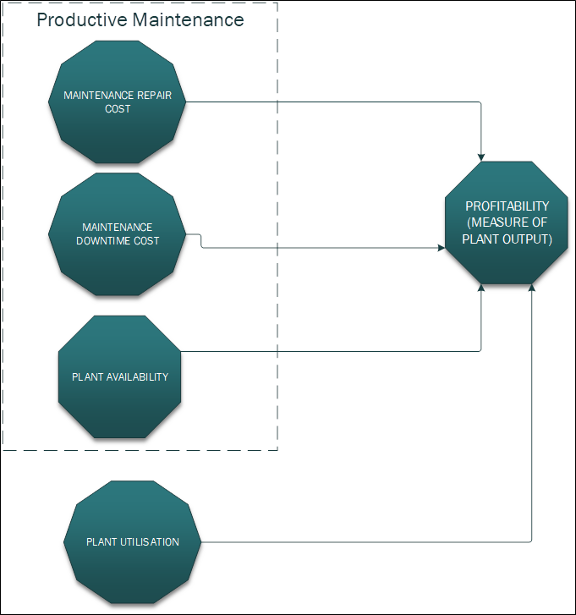

**Figure 2. 7 Conceptual Framework**

**Source: Author’s Construct (2023)**

From the APQC theory, profitability is the product of productivity and price recovery. The productivity is a measure of actual output of a process compared to the actual input in achieving that process output (Alsyouf, 2007). Controllable factors affect productivity whiles uncontrollable factors affect price recovery. These factors negatively or positively affect productivity based on the profit outcome of the process. Price recovery is impacted upon by the fluctuation of the external and uncontrollable factors on price and input cost, thus making it very difficult to trace the productivity from price recovery. Since controllable factors such as resource material, labour, services and equipment availability are the inputs and output of maintenance, they affect the productivity function of the profitability ratio. The conceptual framework quantifies them as factors affecting productive maintenance which invariably affect the throughput. This subsequently results into the achievement of revenues that are generated from the production output. It must be emphasised that there are other controllable factors from operations such as production cost, resource material, reagents, and utilisation that affect productivity of the process. Therefore, the project focuses on assessing the impact of productive maintenance on the profitability; the production output revenues.

REFERENCE

Abhijeet B and Rahul M. D. (2014). “Green Technology for Sustainability”. Urban Life Research in Science and Technology, Vol.6, No. 1, pp. 04-08.

Adams, G. R., and Schvaneveldt, J. D. (2011). Understanding research methods. Addison-Wesley Longman Ltd, 66 pp.

Adediran, Y. A., and Abdulkarim, A. (2012). “Challenges of electronic waste management in Nigeria”. International Journal of Advances in Engineering & Technology, Vol. 4 No. 1, 640 pp.

Ahiadeke, C. (2008). Research Methodology: Theory and Practices in the Social Sciences. Accra: Sundel Services, 102 pp.

Alfred, A., and Adam, R. (2019). “Green Management Matters Regardless”. Academy of Management Perspectives, Vol. 23, No. 3, pp.17-26.

Amahalu, N. (2020). “Effect of Environmental Cost Disclosure on Profitability of Listed Oil and Gas Firms in Nigeria”. International Journal of Academic Research in Accounting, Finance and Management Sciences, Vol. 10 No. 2, pp. 157-170.

Anon, (2012). "Energy Technology Perspectives 2012", pp. 10.

Babbie, E. (2018). The basics of social research. Canada: Thomson Wadsworth, 310 pp.

Banerjee, S. (2012). “Corporate environmental strategies and actions. Management Decision”, Vol. 39, No. 1, pp. 36-44.

Boateng, R. (2014). Research made easy. Accra: PearlsRichards Foundation.

Burns, E., and Groove, W. (2014). Research method. Ergonomics, Vol. 32, No. 3, pp. 237-248.

Chang-Hua, Y. Chien-Yu, C. and Hsiu-Yu, T. (2013). “Perceptions of environmental management and employee job attitudes in hotel firms”. Journal of Human Resources in Hospitality and Tourism, Vol. 12, No. 2, pp. 155-174.

Colicchia,C. Melacini, M. and Perotti, S. (2011). “Benchmarking supply chain sustainability: insights from a field study”. Benchmarking: An International Journal, Vol. 18, No. 5, pp. 705-732.

Cooper, D. R., and Schindler, P. S. (2011). Business research methods. New York: McGrew-Hill Companies.

Costello, M. (2018). “13 Steps to Green Your Business”. Business & Economic Review, Vol. 54, No. 4, pp. 6-9.

Creswell, J. W., and Creswell, J. D. (2017). Research design: Qualitative, quantitative, and mixed methods approach. Sage publications. 25 pp.

Cronstam O. and Gronsberg J. (2017). Factors Influencing the Implementation of Green Management, pp. 51.

Cuerva, M. C., Triguero-Cano, Á., and Córcoles, D. (2014). “Drivers of green and non-green innovation: empirical evidence in Low-Tech SMEs”. Journal of Cleaner Production, Vol. 68, pp. 104-113.

Daly, H. (2010). Steady‐State Economics: Second Edition with New Essays. Washington, DC: Island Press.

Denchak M. (2017). Global Climate Change: What You Need to Know. https://www.nrdc.org/stories/global-climate-change-what-you-need-know. Accessed: August 20, 2021.

Freeman, R., Pierce, J., and Dodd, R. (2010). Environmentalism and the New Logic of Business. New York, NY: Oxford University Press.

Garrod, B., and Chadwick, P. (2011). Environmental management and business strategy: towards a new strategic paradigm. Futures, Vol. 28, No. 1, pp. 37-50.

Green, K. W., Zelbst, P. J., Meacham, J., and Bhadauria, V. S. (2012). “Green supply chain management practices: impact on performance”. Supply Chain Management: An International Journal. Vol. 17, No. 3, pp 290-305

Haden, S. P., Oyler, J., and Humphreys, J. (2019). Historical, practical, and theoretical perspectives on green management: An exploratory analysis. Management Decision, Vol. 47, No. 7, pp. 1041-1055.

Hertwich, E. G. (2015). Consumption and the rebound effect: An industrial ecology perspective. Journal of industrial ecology, Vol. 9, No. 1‐2, pp. 85-98.

Hosseini, A. (2017) “Identification of green management system’s factors: A conceptualized model”, International Journal of Management Science and Engineering Management, pp. 221-228.